DSN Mart Total Sales Prediction
Machine Learning Model Documentation
DSN Bootcamp Qualification Hackathon 2026 — ML Track

1. Problem Overview
DSN Mart operates stores across Nigeria, ranging from corner shops to flagship hypermarkets. The task is to predict total_sales for a given product at a given store, using product attributes (weight, price, category, fat content, shelf visibility) and store attributes (age, size, location tier, format). This is a supervised regression problem evaluated by Root Mean Squared Error (RMSE) on a held-out test set, and it doubles as a qualification round for the DSN AI Bootcamp.

2. Dataset Schema
Column | Description
id | Unique row identifier
product_code | Unique code for the product
product_weight_kg | Weight in kg (some values missing)
fat_content | "Low Fat" or "Regular"
shelf_visibility | Proportion of display area allocated to the product
product_category | Product category text (inconsistent capitalization)
product_price | Listed price of the product
store_code | Unique code for the store
store_age_years | How long the store has been operating
store_size | Small / Medium / Large (some values missing)
store_location_tier | Tier_1 (major cities), Tier_2 (state capitals), Tier_3 (small towns)
store_format | Corner Shop, Standard Supermarket, Superstore, Flagship Hypermarket
total_sales | Target variable — train set only

3. Data Cleaning & Domain Mapping
- product_category is lowercased, whitespace-stripped and collapsed before any downstream step, since the raw column has inconsistent casing (e.g. "Snacks" / "SNACKS" / "snacks").
- A product_name feature is derived from keyword rules over the cleaned category text (currently: yam, potatoes — extendable to a real product_code lookup table).
- Any row whose product_name is yam or potatoes has its product_category forced to "tuber crop", regardless of original spelling or case, so these agricultural items are never split across inconsistent labels.

4. Missing Value Imputation
- product_weight_kg: filled with the median weight for that exact product_code first (weight should be constant per product); rows still missing fall back to the product_category median, then the global median.
- store_size: filled with the most common size within that store_format first; rows still missing fall back to the mode within store_location_tier, then the global mode.
Both imputations were verified on a validation run to leave zero missing values in either column.

5. Feature Engineering
- price_per_weight = product_price / product_weight_kg, capturing value density.
- Log1p transforms of product_price, product_weight_kg, price_per_weight and shelf_visibility to reduce right-skew.
- store_age_years bucketed into new / young / mature / old bands to capture non-linear age effects cheaply.
- Frequency encoding for the high-cardinality columns product_code, store_code and product_category.
- Ordinal encoding for store_size (Small < Medium < Large), which has a natural order.
- One-hot encoding for the low-cardinality nominal columns: fat_content, store_location_tier, store_format, and the age bucket.
- Out-of-fold target encoding (5-fold) for product_code and store_code against the log-transformed target, so the encoding never leaks information from a row into its own fold.

6. Modeling Strategy
The target is log1p-transformed before training (np.log1p(total_sales)) to stabilise variance, and predictions are inverted with np.expm1() before scoring or submission. The pipeline runs 5-fold cross-validation; within each fold it trains LightGBM, XGBoost and CatBoost regressors and averages their predictions (a simple ensemble), then averages the out-of-fold and test predictions across all five folds. If none of those three libraries are installed, the script automatically falls back to scikit-learn's HistGradientBoostingRegressor so the pipeline still runs end-to-end — this fallback is what produced the validation numbers below, since the current environment has no internet access to install LightGBM/XGBoost/CatBoost.
Primary evaluation metric: RMSE on the original (non-log) sales scale, computed both per-fold and as an overall out-of-fold score.

7. Validation Run
Real train.csv / test.csv files were not provided alongside the brief, so the pipeline was validated end-to-end on a synthetic dataset built to match the exact schema (1,600 synthetic training rows, 400 synthetic test rows), using the scikit-learn fallback model described above. This confirms the code runs cleanly and produces a correctly-shaped submission — the RMSE figures below are only meaningful as a sanity check on synthetic data, not as a real leaderboard score.
Fold | RMSE (original scale)
Fold 1 | 1,803.92
Fold 2 | 1,749.75
Fold 3 | 1,852.61
Fold 4 | 1,670.56
Fold 5 | 1,950.07
Mean ± Std | 1,805.38 ± 94.27
Overall OOF RMSE | 1,807.84

On the real competition data, running with pip install lightgbm xgboost catboost will use the actual three-model ensemble described above rather than the fallback.

8. Submission Format
The pipeline writes submission.csv with exactly two columns, id and total_sales, one row per test-set row, predictions clipped at zero (sales cannot be negative). On the synthetic validation run this produced 400 rows with no missing or negative values.

9. Diagnostic Charts
The charts below come from the same synthetic validation run referenced in Section 7 (using the scikit-learn fallback model, since LightGBM/XGBoost/CatBoost aren't installed in this offline environment). They illustrate the diagnostics you should regenerate once real data is available.
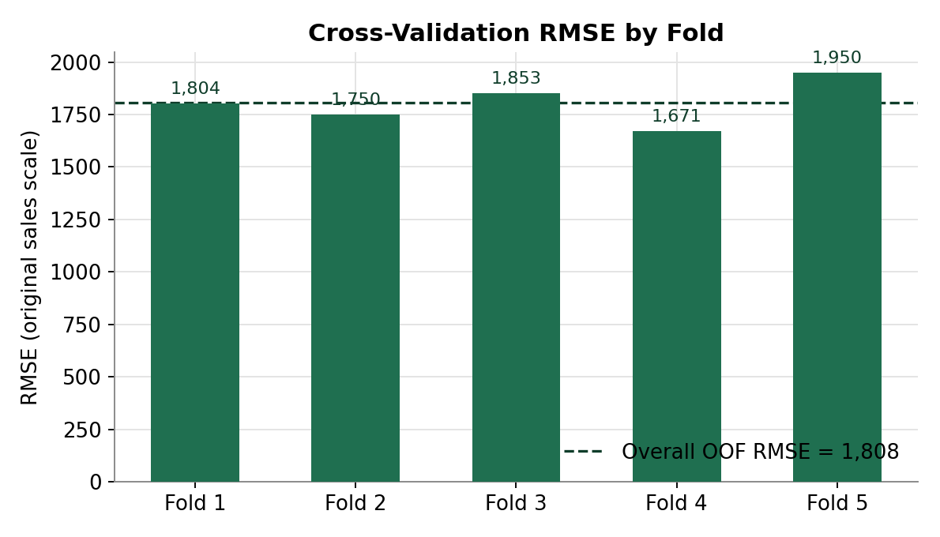
Figure 1. RMSE per cross-validation fold, with the overall out-of-fold RMSE as a reference line.
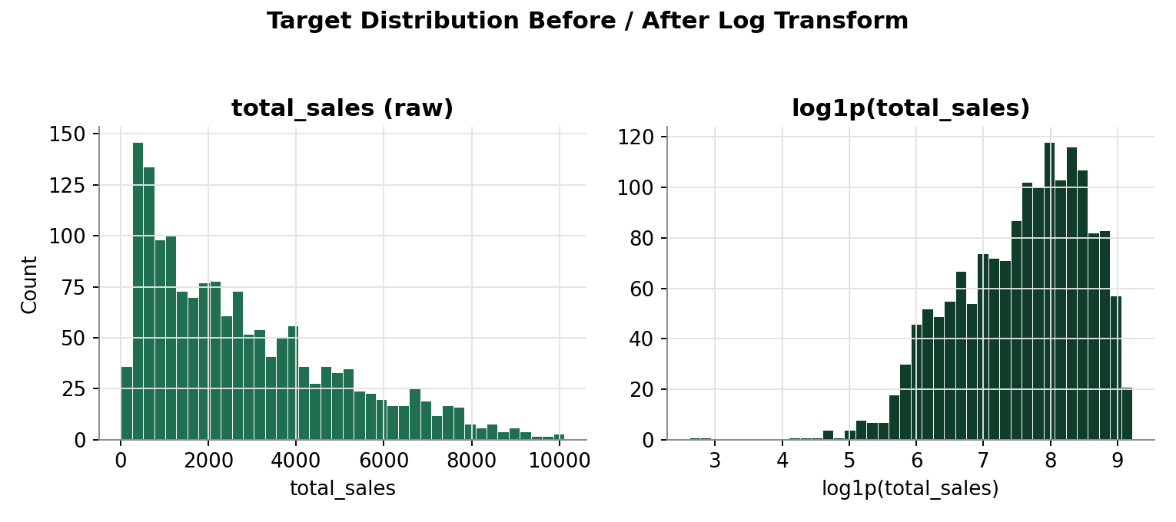
Figure 2. total_sales is right-skewed; log1p transform makes it closer to symmetric, which is why the model is trained on the log scale.
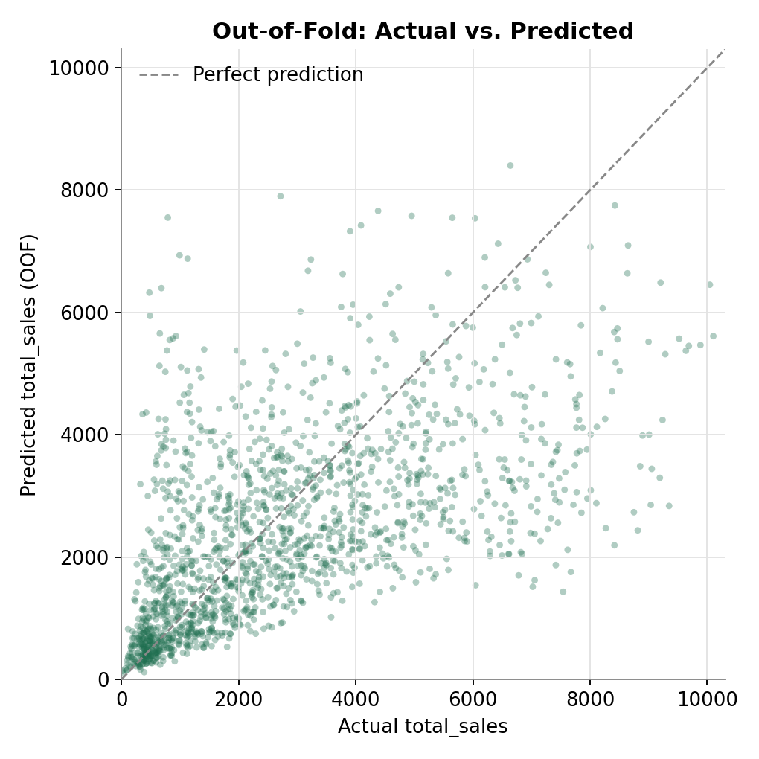
Figure 3. Out-of-fold actual vs. predicted total_sales. Points near the dashed line are well-predicted; the spread here reflects the weak, noisy signal in the synthetic data, not a bug in the pipeline.
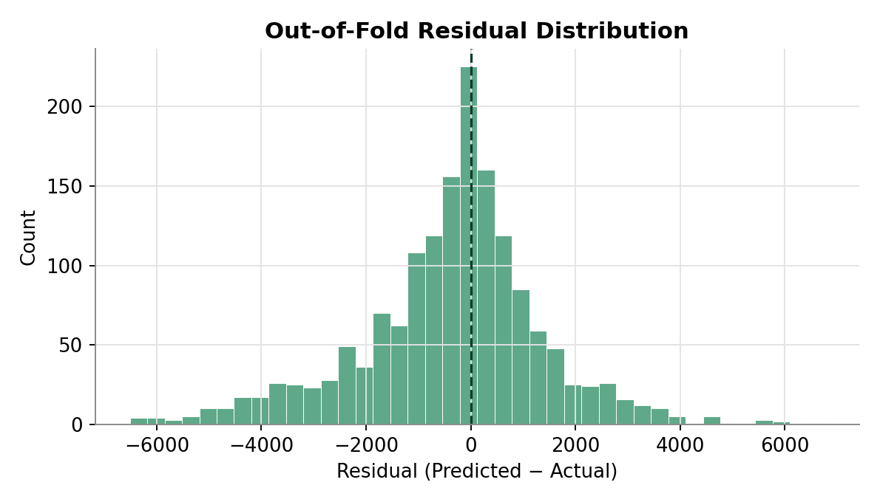
Figure 4. Out-of-fold residuals (predicted minus actual), roughly centered on zero with no strong bias.
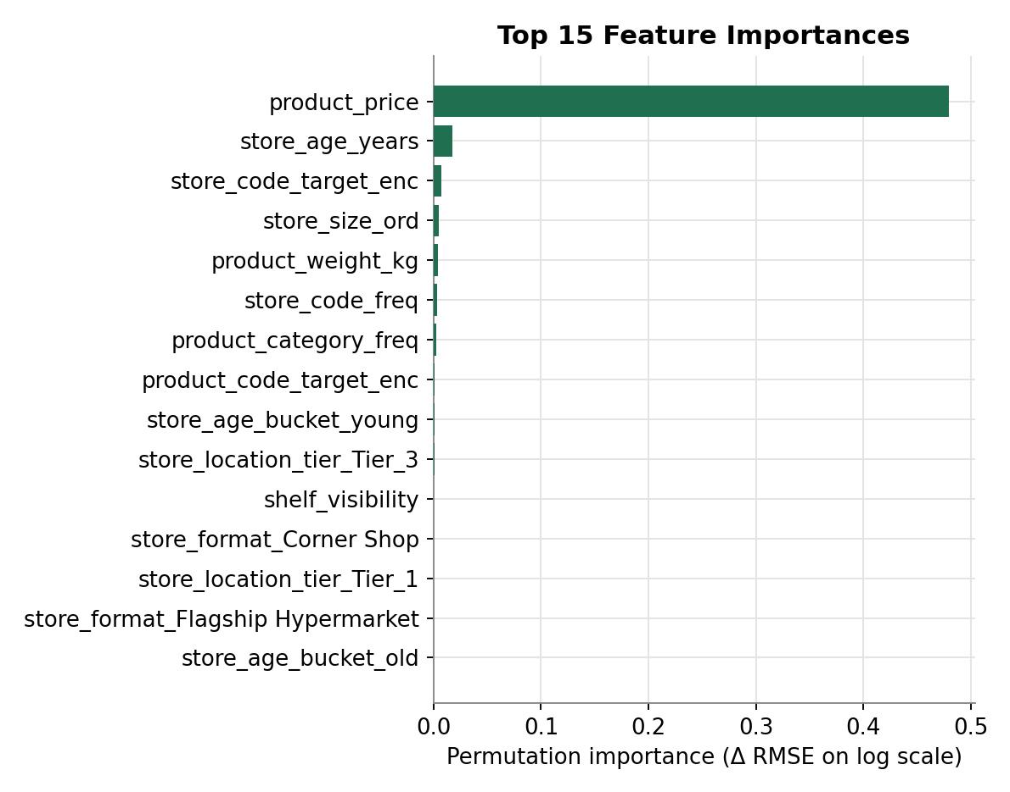
Figure 5. Permutation feature importance (top 15) — the drop in validation RMSE when a feature is shuffled. On the synthetic data, product_price and store_age_years dominate because that's how the synthetic target was constructed; on real data this chart will show which engineered features actually drive sales.

Appendix: Full Pipeline Code (dsn_pipeline.py)
The complete, runnable script referenced throughout this document. It accepts --train, --test and --out arguments and can be run directly: python dsn_pipeline.py --train train.csv --test test.csv --out submission.csv
"""
DSN Bootcamp Qualification Hackathon 2026 - ML Track
End-to-end pipeline: cleaning -> feature engineering -> CV modeling -> submission

Usage:
python dsn_pipeline.py --train train.csv --test test.csv --out submission.csv

Requires: pandas, numpy, scikit-learn, lightgbm, xgboost, catboost
pip install pandas numpy scikit-learn lightgbm xgboost catboost --break-system-packages
"""

import argparse
import warnings
import numpy as np
import pandas as pd
from sklearn.model_selection import KFold
from sklearn.metrics import mean_squared_error
from sklearn.preprocessing import OrdinalEncoder

def rmse(y_true, y_pred):
"""Version-agnostic RMSE (newer sklearn dropped the squared= kwarg)."""
return float(np.sqrt(mean_squared_error(y_true, y_pred)))

warnings.filterwarnings("ignore")

# Optional GBM libraries - imported lazily so the script still runs (with fewer
# models) if one of them isn't installed in the environment.
HAS_LGB = HAS_XGB = HAS_CAT = False
try:
import lightgbm as lgb
HAS_LGB = True
except ImportError:
pass
try:
import xgboost as xgb
HAS_XGB = True
except ImportError:
pass
try:
from catboost import CatBoostRegressor
HAS_CAT = True
except ImportError:
pass

# Fallback so the pipeline still runs end-to-end even if none of the three
# boosting libraries are installed (e.g. offline environments). Swap this
# out for LightGBM/XGBoost/CatBoost in your actual submission run.
from sklearn.ensemble import HistGradientBoostingRegressor

RANDOM_STATE = 42
N_FOLDS = 5

NOMINAL_COLS = ["fat_content", "store_location_tier", "store_format"]
ORDINAL_STORE_SIZE = ["Small", "Medium", "Large"]

# Domain rule-based product name mapping. Extend this dict as you inspect
# product_code / product_category values in the real data.
PRODUCT_NAME_KEYWORDS = {
"yam": "yam",
"potato": "potatoes",
"potatoes": "potatoes",
}
# Categories that should always be folded into "tuber crop" once we know the
# underlying product is a yam or potato.
TUBER_PRODUCT_NAMES = {"yam", "potatoes"}

# ---------------------------------------------------------------------------
# 1. LOAD
# ---------------------------------------------------------------------------
def load_data(train_path: str, test_path: str):
train = pd.read_csv(train_path)
test = pd.read_csv(test_path)
train["__is_train__"] = 1
test["__is_train__"] = 0
if "total_sales" not in test.columns:
test["total_sales"] = np.nan
full = pd.concat([train, test], axis=0, ignore_index=True, sort=False)
return full

# ---------------------------------------------------------------------------
# 2. CATEGORY CLEANING + DOMAIN MAPPING
# ---------------------------------------------------------------------------
def clean_product_category(df: pd.DataFrame) -> pd.DataFrame:
df["product_category"] = (
df["product_category"]
.astype(str)
.str.strip()
.str.lower()
.str.replace(r"\s+", " ", regex=True)
)
return df

def derive_product_name(df: pd.DataFrame) -> pd.DataFrame:
"""Assign an explicit product_name from product_category text (and, if
you have a real product_code -> product_name lookup table, merge that in
here instead of / in addition to the keyword rule)."""

def infer_name(cat: str):
for kw, name in PRODUCT_NAME_KEYWORDS.items():
if kw in cat:
return name
return cat # fall back to the cleaned category itself

df["product_name"] = df["product_category"].apply(infer_name)
return df

def apply_tuber_mapping(df: pd.DataFrame) -> pd.DataFrame:
"""Force yam / potatoes products into a single 'tuber crop' category,
regardless of how they were originally labelled."""
mask = df["product_name"].isin(TUBER_PRODUCT_NAMES)
df.loc[mask, "product_category"] = "tuber crop"
return df

# ---------------------------------------------------------------------------
# 3. MISSING VALUE IMPUTATION
# ---------------------------------------------------------------------------
def impute_weight(df: pd.DataFrame) -> pd.DataFrame:
# Prefer a per-product_code median (weight should be constant per product);
# fall back to per-category median, then global median.
df["product_weight_kg"] = df.groupby("product_code")["product_weight_kg"].transform(
lambda s: s.fillna(s.median())
)
cat_median = df.groupby("product_category")["product_weight_kg"].transform("median")
df["product_weight_kg"] = df["product_weight_kg"].fillna(cat_median)
df["product_weight_kg"] = df["product_weight_kg"].fillna(df["product_weight_kg"].median())
return df

def impute_store_size(df: pd.DataFrame) -> pd.DataFrame:
def mode_or_nan(s):
m = s.mode()
return m.iloc[0] if not m.empty else np.nan

fmt_mode = df.groupby("store_format")["store_size"].transform(mode_or_nan)
df["store_size"] = df["store_size"].fillna(fmt_mode)

tier_mode = df.groupby("store_location_tier")["store_size"].transform(mode_or_nan)
df["store_size"] = df["store_size"].fillna(tier_mode)

global_mode = df["store_size"].mode().iloc[0]
df["store_size"] = df["store_size"].fillna(global_mode)
return df

# ---------------------------------------------------------------------------
# 4. FEATURE ENGINEERING
# ---------------------------------------------------------------------------
def engineer_features(df: pd.DataFrame) -> pd.DataFrame:
# Price per weight ratio (guard against div-by-zero)
df["price_per_weight"] = df["product_price"] / df["product_weight_kg"].replace(0, np.nan)
df["price_per_weight"] = df["price_per_weight"].fillna(df["price_per_weight"].median())

# Log-transform skewed numeric features
for col in ["product_price", "product_weight_kg", "price_per_weight", "shelf_visibility"]:
if col in df.columns:
df[f"log_{col}"] = np.log1p(df[col].clip(lower=0))

# Store age buckets (captures non-linear age effects cheaply)
df["store_age_bucket"] = pd.cut(
df["store_age_years"], bins=[-1, 5, 10, 20, 100], labels=["new", "young", "mature", "old"]
).astype(str)

# Frequency encoding for high-cardinality categoricals
for col in ["product_code", "store_code", "product_category"]:
freq = df[col].value_counts(normalize=True)
df[f"{col}_freq"] = df[col].map(freq)

# Ordinal encoding for store_size (has a natural order)
size_map = {s: i for i, s in enumerate(ORDINAL_STORE_SIZE)}
df["store_size_ord"] = df["store_size"].map(size_map)

# One-hot encode low-cardinality nominal columns
df = pd.get_dummies(df, columns=NOMINAL_COLS + ["store_age_bucket"], drop_first=False)

return df

def target_encode_oof(df: pd.DataFrame, col: str, target: str, n_folds: int = N_FOLDS):
"""Out-of-fold target encoding to avoid leakage. Only uses train rows to
compute encodings; test rows get the full-train-mean encoding."""
train_mask = df["__is_train__"] == 1
train_df = df.loc[train_mask, [col, target]].copy()
global_mean = train_df[target].mean()

oof_enc = pd.Series(index=train_df.index, dtype=float)
kf = KFold(n_splits=n_folds, shuffle=True, random_state=RANDOM_STATE)
for fold_tr_idx, fold_val_idx in kf.split(train_df):
fold_tr = train_df.iloc[fold_tr_idx]
means = fold_tr.groupby(col)[target].mean()
oof_enc.iloc[fold_val_idx] = train_df.iloc[fold_val_idx][col].map(means)
oof_enc = oof_enc.fillna(global_mean)

full_means = train_df.groupby(col)[target].mean()
test_enc = df.loc[~train_mask, col].map(full_means).fillna(global_mean)

enc_col = f"{col}_target_enc"
df[enc_col] = np.nan
df.loc[train_mask, enc_col] = oof_enc.values
df.loc[~train_mask, enc_col] = test_enc.values
return df

# ---------------------------------------------------------------------------
# 5. MODELING
# ---------------------------------------------------------------------------
def get_feature_columns(df: pd.DataFrame):
drop_cols = {
"id", "total_sales", "__is_train__", "log_total_sales",
"product_code", "store_code", # raw high-cardinality IDs (freq/target-encoded instead)
"product_category", "product_name", "store_size", # raw text (encoded versions kept)
"fold",
}
return [c for c in df.columns if c not in drop_cols]

def train_cv(df: pd.DataFrame, feature_cols, n_folds: int = N_FOLDS):
train_df = df[df["__is_train__"] == 1].reset_index(drop=True)
test_df = df[df["__is_train__"] == 0].reset_index(drop=True)

X = train_df[feature_cols]
y = train_df["log_total_sales"]
X_test = test_df[feature_cols]

kf = KFold(n_splits=n_folds, shuffle=True, random_state=RANDOM_STATE)

oof_preds = np.zeros(len(train_df))
test_preds = np.zeros(len(test_df))
fold_rmses = []

models_used = []
if HAS_LGB:
models_used.append("lightgbm")
if HAS_XGB:
models_used.append("xgboost")
if HAS_CAT:
models_used.append("catboost")
use_fallback = not models_used
if use_fallback:
models_used.append("sklearn_hgb (fallback - install lightgbm/xgboost/catboost for the real run)")

for fold, (tr_idx, val_idx) in enumerate(kf.split(X), start=1):
X_tr, X_val = X.iloc[tr_idx], X.iloc[val_idx]
y_tr, y_val = y.iloc[tr_idx], y.iloc[val_idx]

fold_val_pred = np.zeros(len(val_idx))
fold_test_pred = np.zeros(len(X_test))
n_models = 0

if HAS_LGB:
model = lgb.LGBMRegressor(
n_estimators=2000, learning_rate=0.03, num_leaves=31,
subsample=0.8, colsample_bytree=0.8, random_state=RANDOM_STATE,
)
model.fit(
X_tr, y_tr, eval_set=[(X_val, y_val)],
callbacks=[lgb.early_stopping(100, verbose=False)],
)
fold_val_pred += model.predict(X_val)
fold_test_pred += model.predict(X_test)
n_models += 1

if HAS_XGB:
model = xgb.XGBRegressor(
n_estimators=2000, learning_rate=0.03, max_depth=6,
subsample=0.8, colsample_bytree=0.8, random_state=RANDOM_STATE,
early_stopping_rounds=100, eval_metric="rmse",
)
model.fit(X_tr, y_tr, eval_set=[(X_val, y_val)], verbose=False)
fold_val_pred += model.predict(X_val)
fold_test_pred += model.predict(X_test)
n_models += 1

if HAS_CAT:
model = CatBoostRegressor(
iterations=2000, learning_rate=0.03, depth=6,
random_state=RANDOM_STATE, verbose=False,
early_stopping_rounds=100,
)
model.fit(X_tr, y_tr, eval_set=(X_val, y_val), use_best_model=True)
fold_val_pred += model.predict(X_val)
fold_test_pred += model.predict(X_test)
n_models += 1

if use_fallback:
model = HistGradientBoostingRegressor(
max_iter=500, learning_rate=0.05, random_state=RANDOM_STATE
)
model.fit(X_tr, y_tr)
fold_val_pred += model.predict(X_val)
fold_test_pred += model.predict(X_test)
n_models += 1

fold_val_pred /= n_models
fold_test_pred /= n_models

oof_preds[val_idx] = fold_val_pred
test_preds += fold_test_pred / n_folds

# RMSE on the ORIGINAL sales scale (invert the log1p transform first)
fold_rmse = rmse(np.expm1(y_val), np.expm1(fold_val_pred))
fold_rmses.append(fold_rmse)
print(f"[Fold {fold}/{n_folds}] models={models_used} RMSE={fold_rmse:,.4f}")

overall_rmse = rmse(np.expm1(y), np.expm1(oof_preds))
print(f"\nOverall OOF RMSE (original scale): {overall_rmse:,.4f}")
print(f"Fold RMSE mean/std: {np.mean(fold_rmses):,.4f} / {np.std(fold_rmses):,.4f}")

return test_preds, test_df["id"].values, overall_rmse

# ---------------------------------------------------------------------------
# 6. PIPELINE ENTRY POINT
# ---------------------------------------------------------------------------
def run_pipeline(train_path: str, test_path: str, out_path: str):
df = load_data(train_path, test_path)

df = clean_product_category(df)
df = derive_product_name(df)
df = apply_tuber_mapping(df)

df = impute_weight(df)
df = impute_store_size(df)

df = engineer_features(df)

# log-transform the target (train rows only; test rows are NaN)
df["log_total_sales"] = np.log1p(df["total_sales"])

# OOF target encoding for the highest-cardinality identifiers
for col in ["product_code", "store_code"]:
df = target_encode_oof(df, col, "log_total_sales")

feature_cols = get_feature_columns(df)
print(f"Using {len(feature_cols)} features.")

test_preds_log, test_ids, oof_rmse = train_cv(df, feature_cols)

# Inverse-transform predictions back to the original sales scale
test_preds = np.expm1(test_preds_log)
test_preds = np.clip(test_preds, 0, None) # sales can't be negative

submission = pd.DataFrame({"id": test_ids, "total_sales": test_preds})
submission.to_csv(out_path, index=False)
print(f"\nSaved submission to {out_path}")
return submission, oof_rmse

if __name__ == "__main__":
parser = argparse.ArgumentParser()
parser.add_argument("--train", default="train.csv")
parser.add_argument("--test", default="test.csv")
parser.add_argument("--out", default="submission.csv")
args = parser.parse_args()
run_pipeline(args.train, args.test, args.out)

